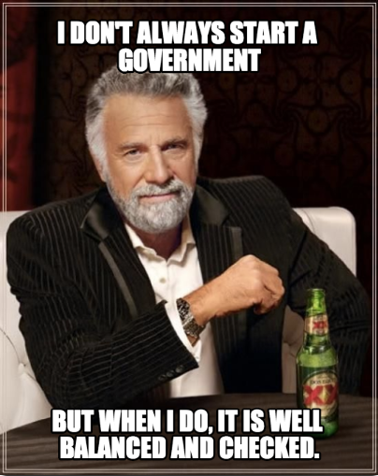
Meme Assignment
POL 51: American Government
Fall 2022
Suggested Due Date: October 9 on Your Blog
15 points of Final Grade

From http://sharonjennings.weebly.com/vocabulary.html - you may find great inspiration at this site, but you MAY NOT COPY any of these memes (or any other ones)- the assignment requires you to create a new one.

For this assignment, you will create a meme that explains an American Government concept we have covered so far in class. You may choose any of the concepts we’ve covered so far, from your assigned readings and class discussions. Select a concept, and make a meme; you may reuse images, but the words must be your original contribution. Then write a short (4-5 paragraphs) reflection explaining the concept and the meme. The reflection is public, shared writing, and so should be written, revised, proofread, and only then finally published; in other words, don’t leave it to the last minute. You must also choose a concept that no other student has already meme-d, so it is advantageous to you to complete the assignment sooner rather than later. The meme and reflection essay should be posted as a blog post to your blog by October 9. You must also grade yourself according to the rubric below. Be sure to include a paragraph at the end of the assignment grading your work and explaining the grade you gave yourself. You may find the presubmission checklist at the end of this sheet helpful.

 | Concept | Reflection
15 | Meme clearly explains or illustrates a concept from American government, and does not copy a previously submitted meme. | Essay explains the American government concept clearly, using at least one properly cited quote or paraphrase from assigned course readings. Essay is of required length (4-5 paragraphs), well-written, with extremely few or no grammar, spelling, or typographical errors.
7.5 | Meme references a concept from American government, but is not very specific or illustrative. Meme is somewhat similar to another student's or existing American government meme. | Essay somewhat explains the American government concept but is not very clear. Essay uses a quote or paraphrase from assigned course readings, but does not properly cite it. Essay is of somewhat shorter or longer than the required length (4-5 paragraphs), and is somewhat well-written, with some grammar, spelling, or typographical errors.
0 | Meme makes little to no reference to a concept from American government, or repeats almost exactly a previously submitted or existing meme. | Essay does not really explain the American government concept. Essay does not include any reference to assigned course readings. Essay is of much shorter or longer than the required length (4-5 paragraphs), and is poorly written, with many grammar, spelling, or typographical errors.

Some examples of scholarly(ish) memes: https://twitter.com/ResearchMark, http://feministryangosling.tumblr.com/ (which actually began as a grad student’s study guide), and http://irryangosling.tumblr.com/ (no copying any of these directly). You are certainly not limited to actor based memes- use whatever base meme you like- Condescending Wonka, Bad Luck Brian, One Does Not Simply (you can use https://imgflip.com/memegenerator/27596988/Free or any other meme generator you like).

Presubmission Checklist
- Is it a meme that you created yourself (not copied from elsewhere)?
- Does the meme relate to something we’ve covered in class?
- Does the essay explain the meme?
- Does it include a properly cited quote or paraphrase from your reading?
- Do all claims/assertions have support?
- Does everything in the essay serve the purpose of the essay?
- Does it conform to the standards of formal academic writing?
  - Did you spellcheck?
  - Did you proofread?
  - Did you get a friend to read and give you feedback, then revise based on that feedback?
  - Did you write a self-grading assessment according to the provided rubric, assigning yourself a number of points and explaining why your work earns those points?

