Name College Now HUM 1 Date

Art!
Your Task: As we read the following intro to Pop Art, annotate you text using the following guiding questions:
- How does Pop Art exemplify the mentality behind Modernist Art, namely "a break from tradition"?
- What does Pop Art have in common with Dada art that we have seen and discussed?
- Why is Pop Art called "Pop Art"?
- Can you make connections to Pop Art to other movements we've studied (Fauvism, Cubism..)?

Pop art is an art movement that emerged in the mid-1950s in Britain and in the late 1950s in the United States. Pop art presented a challenge to traditions of fine art by including imagery from popular culture such as advertising, news, etc. In pop art, material is sometimes visually removed from its known context, isolated, and/or combined with unrelated material. The concept of pop art refers not as much to the art itself as to the attitudes that led to it.
Pop art employs aspects of mass culture, such as advertising, comic books and everyday objects. Due to its utilization of found objects and images it is similar to Dada. Pop art is aimed to employ images of popular as opposed to elitist culture in art, emphasizing the banal or kitschy elements of any given culture, most often through the use of sarcasm or irony. It is also associated with the artists' use of mechanical means of reproduction or rendering techniques such as screen printing.
Pop art often takes as its imagery that which is currently in use in advertising. Product labeling and logos figure prominently in the imagery chosen by pop artists, like in the Campbell's Soup Cans labels, by Andy Warhol.

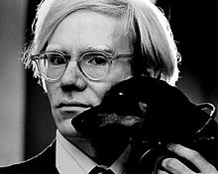

Andy Warhol (August 6, 1928 – February 22, 1987)

- considered the "Pope of Pop"
- The Factory- a famous gathering place that brought together distinguished intellectuals, drag queens, artists, writers
- managed and produced the Velvet Underground, a rock band which had a strong influence on the evolution of punk rock music
- notable as a gay man who lived openly as such before the gay liberation movement

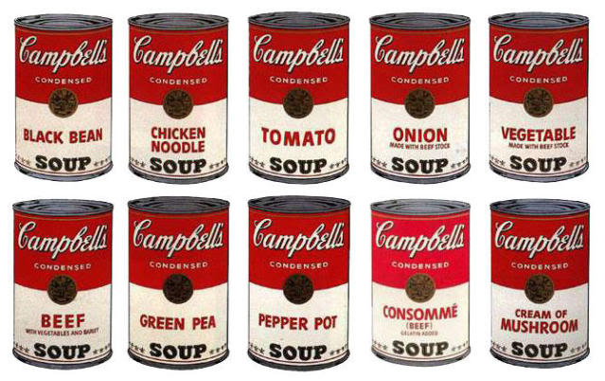

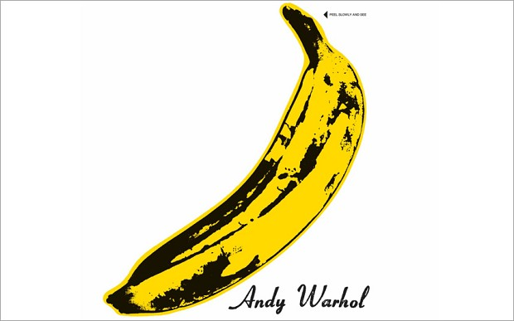

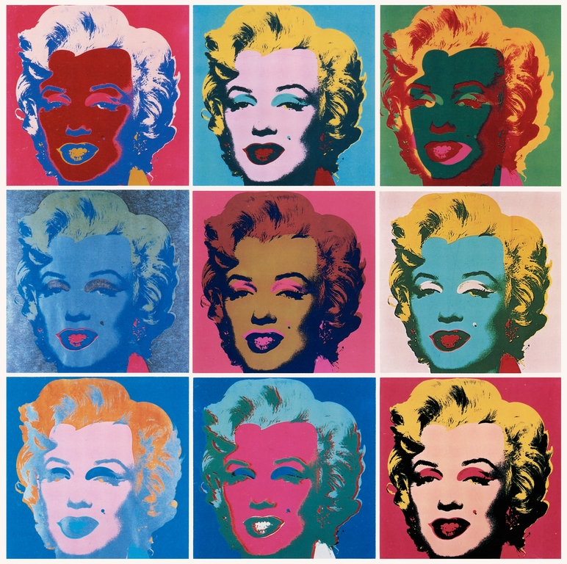

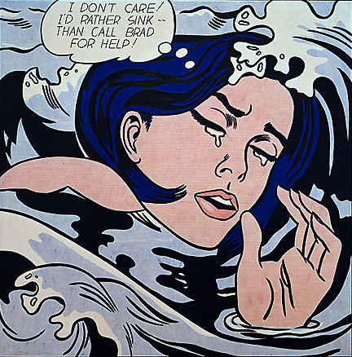
Roy Lichtenstein, Drowning Girl, 1963
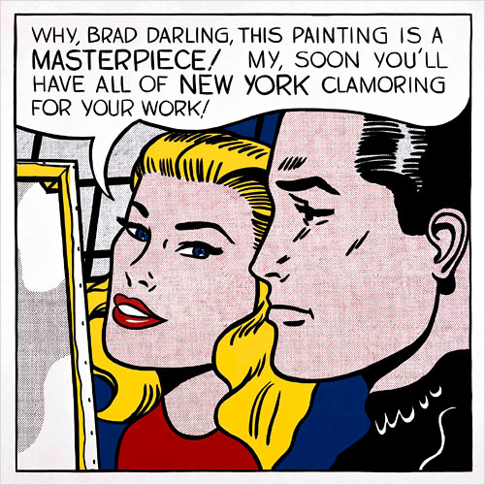
Roy Lichtenstein, Masterpiece, 1962

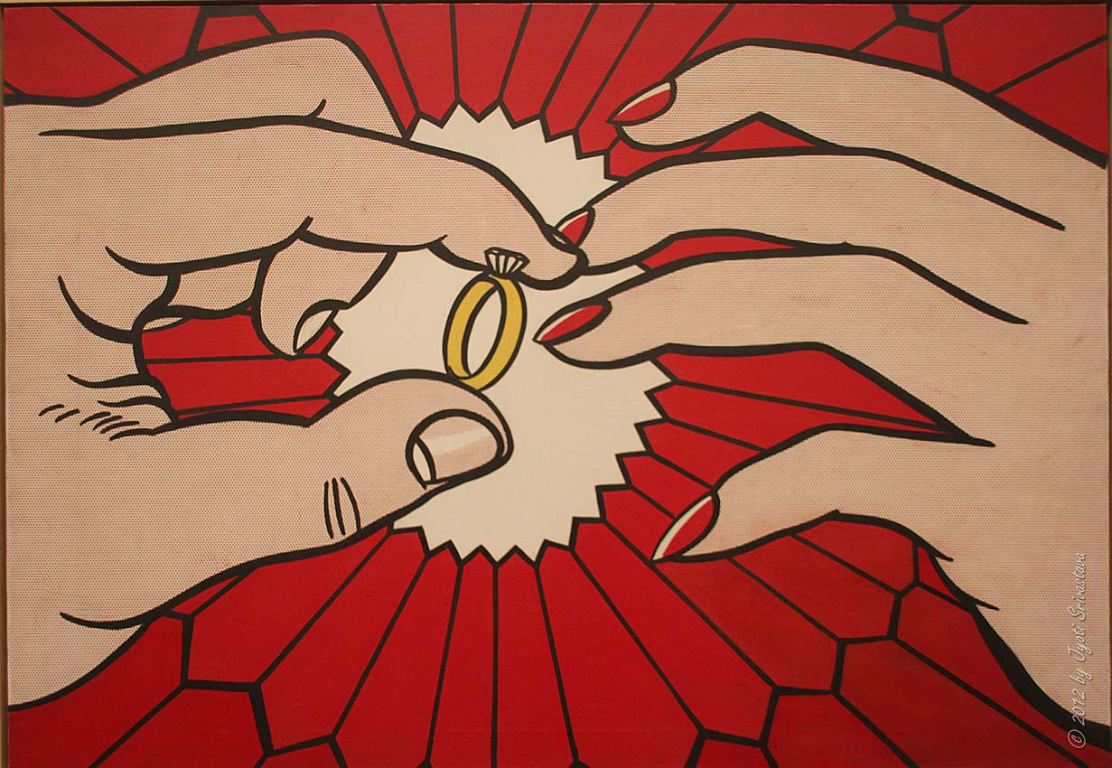
Roy Lichtenstein, The Ring (Engagement), 1962

Tom Wesselmann, Dropped Bra, 1980

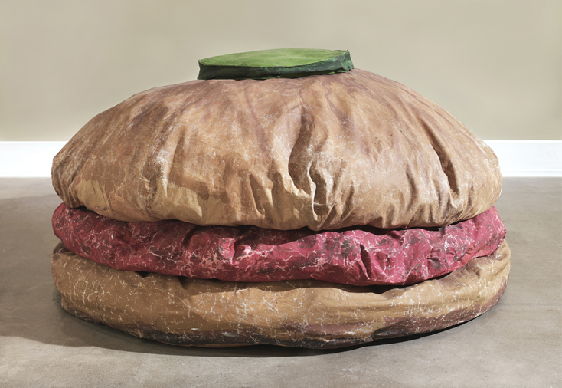
Claes Oldenburg, Soft Hamburger, 1962

Reflection HW:

If Pop Art were born today as opposed to the late 1950's, how would it be different? Consider what is currently going on in society, politics, food, fashion, technology, households. Use your knowledge of Pop Art from today's lesson to make a strong argument.

Bring in one picture/example of what you think Pop Art would be today.
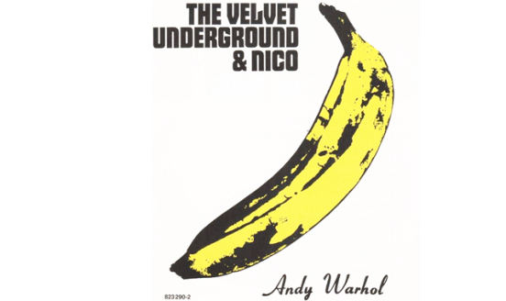

As we listen to the Velvet Underground's "Sunday Morning," consider the following Guiding Questions:

- How do the underlined terms connect to the Modernist mentality?
- How do the mood and delivery of the song seem contradictory to the lyrics? Can you make a connection to any of the visual art we viewed yesterday?

“Sunday Morning”
Sunday morning
Brings the dawn in
It's just a restless feeling by my side
Early dawning
Sunday morning
It's just the wasted years so close behind
Watch out the world's behind you
There's always someone around you who will call
It's nothing at all
Sunday morning
And I'm falling
I've got a feeling I don't want to know
Early dawning
Sunday morning
It's all the streets you crossed, not so long ago
Watch out the world's behind you
There's always someone around you who will call
It's nothing at all

Make some connections between "Femme Fatale" and Roy Lichtenstein's works from yesterday. What themes are present?

“Femme Fatale”
Here she comes
You'd better watch your step
She's going to break your heart in two, it's true
It's not hard to realize
Just look into her false-colored eyes
She builds you up to just put you down
what a clown
'Cause everybody knows (She's a femme fatale)
The things she does to please (She's a femme fatale)
She's just a little tease (She's a femme fatale)
See the way she walks
Hear the way she talks
You're written in her book
You're number 37, have a look
She's going to smile to make you frown, what a clown
Little boy, she's from the street
Before you start you're already beat
She's gonna play you for a fool, yes it's true
'Cause everybody knows (She's a femme fatale)
The things she does to please (She's a femme fatale)
She's just a little tease (She's a femme fatale)
See the way she walks Hear the way she talks
She's a femme fatale

Before you go: Write a paragraph reflection addressing the following prompt:

Why do you think Andy Warhol was considered "The Pope of Pop Art"? Why were his contributions to the movement unique? Why might his contributions be considered more substantial or meaningful to Modernist art than other Pop artists to whom we were introduced the last two days?

College Now HUM 1

Pop Art Presentation Questions

- After Andy Warhol questions, before the images: “How do the following works fall in line with the Modernist mentality? to the description of Pop Art from our intro?”

- Before images of Lichtenstein: “What is Roy Lichtenstein's making fun of, satirizing about American culture? Remember we're talking the 1960's here.”

(3) Before Wessleman: “Ummmmm, what's the message here?”

(4) After the hamburger: “Why did Claes Oldenburg choose the hamburger as opposed to Roast Beef or lasagna?”

