The Quest for Racial Equality

a. The Dutch took the first African-American slaves to America in 1619 and during the 17th & 18th century thousands of slaves were imported to the American colonies, especially those in the South.

b. For 250 years, until the end of the Civil War, slavery was a fact of American life.

c. The Emancipation Proclamation was issued by Abraham Lincoln in 1863 but it wasn’t until 1865- the 13th Amendment of the Constitution that all slaves were finally freed.

d. Jim Crow laws were passed in the South as a means to legitimize segregation. African-Americans continued to suffer inequities until the Civil Rights Movement of the 1960’s.

The Harlem Renaissance
a. WWI provided African-American’s with new opportunities in education and employment. During and after the war over five million African-American’s migrated from the South to the northern states. (Also known as the Great Migration.)
b. NYC became the center of economic opportunity , as well as the melting pot for black people from other parts of the world.
c. Whites became frustrated and feared black competition for jobs. This lead to fierce race riots in over 25 cities during the “bloody summer” of 1919.

d. Between 1920-1940 the quest for racial equality and a search for self-identity among African-American inspired an upsurge of creative expression in the arts. Centered in Harlem—poets, painters, musicians and dancers forged the movement that came to be known as the Harlem Renaissance.

-Langston Hughes-A Dream Deferred
Name_______________________________________________________Date_________pd__________________
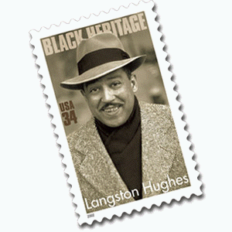 | Langston Hughes was one of the chief voices of the Harlem Renaissance and a noted poet and author. Hughes' poems gave voice to an entire generation of African Americans and their experiences, feelings, thoughts, and dreams.

Directions: Read the poem and answer the accompanying questions.
Poem | Questions
Harlem [Dream Deferred]  What happens to a dream deferred?  Does it dry up  like a raisin in the sun?  Or fester like a sore—  And then run?  Does it stink like rotten meat?  Or crust and sugar over—  like a syrupy sweet?  Maybe it just sags  like a heavy load.  Or does it explode?  By Langston Hughes 1902–1967 | 1. How many lines are in the poem? Identify the rhyme scheme.  2. Reread line 1 of the poem. Which of the following is a synonym  for the word deferred?  a. postponed b. accomplished  c. strengthened d. inspired  3. What imagery does Hughes use? (How does the poet use the 5  senses in the poem?) Give 2 specific examples from the poem.  -  -  4. How do the words; “fester,” “stink,” “rotten,” create the mood of the poem? What is the mood of the poem?  5. How are the words; “fester,” “stink,” “rotten,” similar?  6. What examples of figurative language(simile, metaphor, symbolism) is used in the poem? At least 2 specific examples (there are 5).  -  -  7. What do you think the message or the theme of the poem is? What does the poem say about dreams that are deferred/postponed?
II. Why do you think Hughes wrote the poem? Take a look at the title too!

Langston Hughes-“I Dream A World”

Name_________________________________________________Date_______________________pd_____
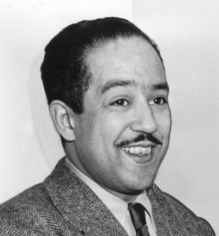

Poem | Questions
I Dream A World  I dream a world where man  No other man will scorn,  Where love will bless the earth  And peace its paths adorn  I dream a world where all  Will know sweet freedom's way,  Where greed no longer saps the soul  Nor avarice blights our day.  A world I dream where black or white,  Whatever race you be,  Will share the bounties of the earth  And every man is free,  Where wretchedness will hang its head  And joy, like a pearl,  Attends the needs of all mankind-  Of such I dream, my world!  By Langston Hughes 1902–1967 | 1. Identify the rhyme scheme.  2. How is the poem narrated?  3. Find 2 examples of personification in the poem:  -  -  4. How does Hughes use repetition in this poem?  What is the effect?  5. For whom do you think Hughes wrote this poem for?  6. What tone does the poet use? (Look at diction.)  7. What theme(s) do you think this poem explores?
II. If Hughes wrote this poem today, what would he dream of for this world? What issues do you think he would explore in his poem?(1 paragraph)

Name_________________________________________________Date______________________pd_____
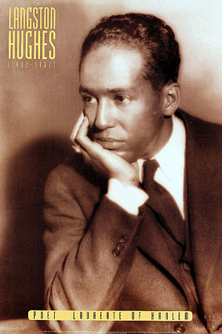 | Langston Hughes was one of the chief voices of the Harlem Renaissance and a noted poet and author. Hughes' poems gave voice to an entire generation of African Americans and their experiences, feelings, thoughts, and dreams.

Directions: Read the poem and answer the accompanying questions:
Poem: | Questions:
Dreams  Hold fast to dreams  For if dreams die  Life is a broken-winged bird  That cannot fly.  Hold fast to dreams  For when dreams go  Life is a barren field  Frozen with snow.  By Langston Hughes 1902–1967 | 1. How many lines are in the poem Dreams?  2. How many sentences is the poem?  3. How many stanzas does the poem include?  4. What metaphor does Hughes use in stanza 1?  What 2 things does he compare?  5. What metaphor does Hughes use in stanza 2?  What 2 things does Hughes compare?  6. What kind of dream would a "broken-winged bird"  represent?  7. How about a "field frozen in snow"?  8. What do you think Hughes was trying to convey about dreams by using these metaphors? Theme?

II. What metaphor(s) would you use if you were writing a poem about dreams? Why?

I, Too, Sing America
by Langston Hughes

I, too, sing America.
I am the darker brother.
They send me to eat in the kitchen When company comes,
But I laugh,
And eat well,
And grow strong.
Tomorrow,
I'll be at the table When company comes. Nobody'll dare
Say to me,
"Eat in the kitchen," Then.
Besides,
They'll see how beautiful I am And be ashamed--
I, too, am America.

The Negro Speaks of Rivers
by Langston Hughes

I’ve known rivers:
I’ve known rivers ancient as the world and older than the flow of human blood in human veins.

My soul has grown deep like the rivers.

bathed in the Euphrates when dawns were young.
I built my hut near the Congo and it lulled me to sleep.
I looked upon the Nile and raised the pyramids above it.
I heard the singing of the Mississippi when Abe Lincoln went down to New Orleans, and I’ve seen its muddy bosom turn all golden in the sunset.

I’ve known rivers:
Ancient, dusky rivers.

My soul has grown deep like the rivers.

Harlem Renaissance

Between 1920-1940 the quest for racial equality and a search for self-identity among African-American inspired an upsurge of creative expression in the arts. Centered in Harlem—poets, painters, musicians and dancers forged the movement that came to be known as the Harlem Renaissance.

I. Poet-Langston Hughes (1902-1967)
Harlem Dream Deferred ( A Meditation on the “bloody summer” of 1919)
I Dream A World
Dreams

II. Artist- Jacob Lawrence (1917-2000)
a. one of the most notable artist s of the 20th century
b. Lawrence’s technique, a mix of cubism, African influences, features flat, local colors and angular
abstract forms
c. committed his work to exploring social and racial issues
d. The Great Migration Series is one of his most famous collections, which includes narrative content
e. Lawrence largely drew on textual sources by doing research prior to painting the series
f. the paintings comprise largely of bold rhythms and vigorous geometric shapes

JACOB LAWRENCE (1917–2000)
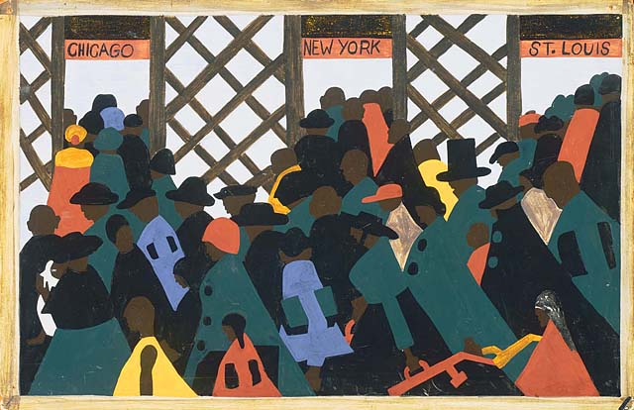
The Migration of the Negro
JACOB LAWRENCE (1917–2000)

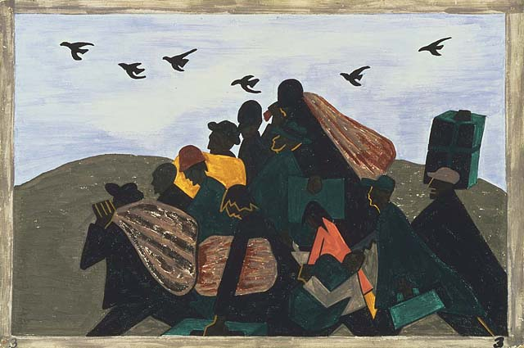
In every town Negroes were leaving by the hundreds to go North and enter into Northern industry.
JACOB LAWRENCE (1917–2000)

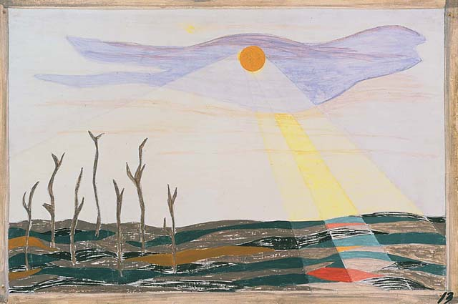
Due to the South's losing so much labor, the crops were left to dry and spoil.

JACOB LAWRENCE (1917–2000)

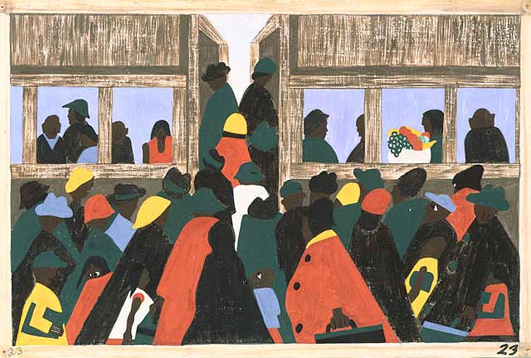
And the migration spread.

JACOB LAWRENCE (1917–2000)

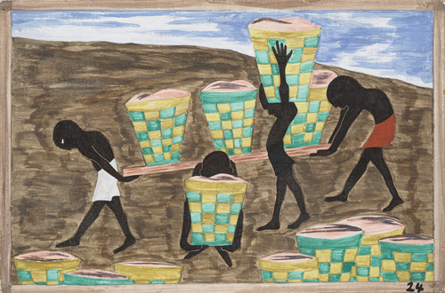

Child labor and a lack of education was one of the other reasons for people wishing to leave their homes

JACOB LAWRENCE (1917–2000)

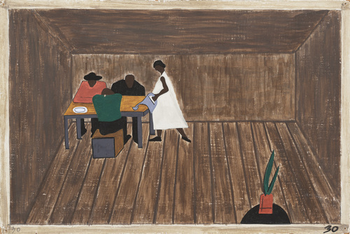
In every home people who had not gone North met and tried to decide if they should go North or not

JACOB LAWRENCE (1917–2000)

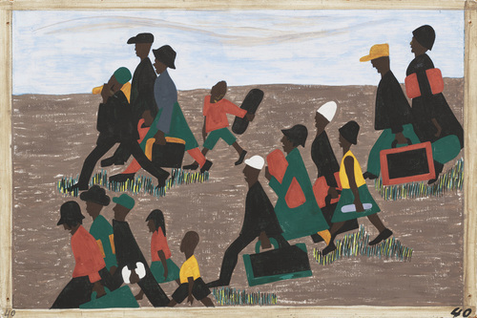

The migrants arrived in great numbers
JACOB LAWRENCE (1917–2000)

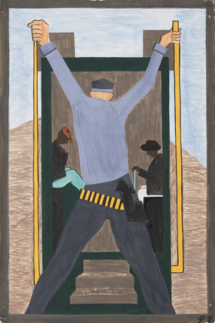

They also made it very difficult for migrants leaving the South. They often went to railroad stations and arrested the Negroes wholesale, which in turn made them miss their train

JACOB LAWRENCE (1917–2000)

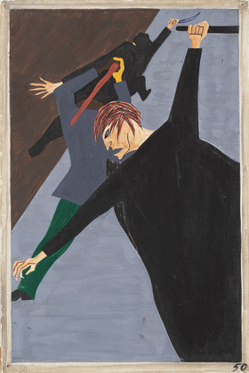
Race riots were very numerous all over the North because of the antagonism that was caused between the Negro and white workers. Many of these riots occurred because the Negro was used as a strike breaker in many of the Northern industries.

JACOB LAWRENCE (1917–2000)

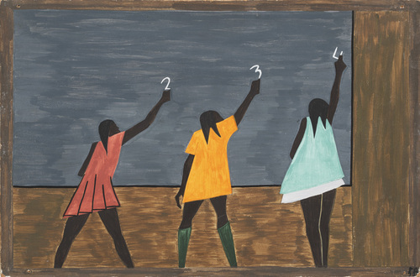

In the North the Negro had better educational facilities.

Hum 1
Name__________________________________________________________date________pd______

Jacob Lawrence “The Great Migration” Series
Background Info: The sixty-panel Migration Series, are shared between MoMA and the Phillips Collection in Washington, D.C. Lawrence took as his subject the exodus of African Americans from the rural South to Northern cities during and after World War I, when industry's demand for workers attracted them in vast numbers. As the son of migrants, Lawrence had a personal connection to the topic. He researched the subject extensively and wrote the narrative before making the paintings, taking seriously the dual roles of educator and artist.
Lawrence was influenced by the work of the Mexican muralists and earlier artists such as Goya, but he drew his stylistic inspiration primarily from the Harlem community in which he lived. The vivid pattern and color—created in tempera paint as Lawrence worked on all the panels at once—reflect an aesthetic that itself had migrated from the South.
*Taken from http://www.moma.org

Directions: Look closely at the panels from The Migration Series. Answer the following questions using the panel you (and your partner) were assigned. Be sure to remember this is one panel in a series. Also, keep in mind, how Lawrence and Hughes may be similar in their content. What connections can we make between the two mediums?

Questions:

1. Look in the bottom left of the painting to determine what number of the series you were assigned. Panel #________

b. Just as important to where in the series the panel fits, is its subtitle. What does the subtitle reveal about the panel?

2. Just like in song, there is a rhythm to Langston Hughes’ poetry. Many of his poems have rhythm and a beat. He often repeats words or lines to help make a pattern so you can hear this rhythm. Art can also have rhythm by repeating patterns, lines, colors etc.

Jacob Lawrence painted with a lot of repeated patterns, to make figures appear to be moving. What does Lawrence repeat in his panel(s) to make a pattern or a rhythm? The same shape? Color? Person?

2a. What do you notice about the figures? What do most of them or all have in common?

Why do you think the artist did this?

3. What is the setting of your panel? Can you tell whether it is North or South?

What colors are used to depict the setting? What do you think the artist is trying to convey about setting with his choice of colors?

4. Artists can use color or shapes to create a mood. (Ex. Blue might mean sad. Jagged lines might mean excitement.) What are the
dominant colors in your assigned panel?

What mood do you feel when you look at The Migration Series? What mood does the panel evoke?

4. What story of the Great Migration does Lawrence attempt to capture in the panel? What do you think he was trying to convey via
this painting?

**Summary Quick Write: Based on our exploration of the Harlem Renaissance and using your notes, classwork etc... answer the following:

How do Lawrence’s paintings and Hugh’s poetry, represent the life and changing roles of African Americans during the Harlem Renaissance and The Great Migration? Compare and contrast the subject of Lawrence’s painting and the subject of Hugh’s poems. Compare and contrast imagery, mood, and tone, pointing to specific visual and poetic evidence.

