**Is a Picture Worth a Thousand Words?**

**Michelle Turnbull**

James Madison High School

College Now HUM1 Professional Development Workshop

October 8, 2015

**Part I**

Define *ekphrasis*: “A description of a visual work of art; when one medium of art attempts to relate to another medium by describing its essence and form.”

**Student Task: *Ekphrasis* in a painting/poem:**

Individual work, with the below questions on Smart Board

1. Look at the image of Marcel Duchamp’s *Nude Descending a Staircase* (1912), and then read X.J. Kennedy’s “Nude Descending a Staircase.” Then, answer the following questions quietly on your own.
2. What emotions do you think the poet felt when he/she looked at the painting? Why *this* painting?
3. Who is this woman?
4. What details of the image of the painting and the poem are similar and/or different?
5. What aspects of the painting do you think serve as inspiration for the poem?

Pair/group work, with below questions on Smart Board

1. Again looking at Marcel Duchamp’s *Nude Descending a Staircase* (1912) and X.J. Kennedy’s “Nude Descending a Staircase,” answer the following questions with your partner(s).
2. Which lines of the poem describe the painting?
3. Which lines of the poem interpret the painting?
4. How does the poem analyze the painting?
5. Why does it matter that poets write poems about paintings? Why bother? And why should we bother studying the *ekphrasis* of the humanities? In other words, so what?

**Part II**

Review Modernism, with the below on the Smart Board

What is Modernism?

* The following are characteristics of Modernism:
* Marked by a strong and intentional break with tradition and break from the past. This break includes a strong reaction against established religious, political, and social views.
* This resulted in turning to untraditional sources for inspiration.
* Belief that the world is created in the act of perceiving it; that is, the world is what we say it is.
* There is no such thing as absolute truth. All things are relative.
* No connection with history or institutions. Their experience is that of alienation, loss, and despair.
* Championship of the individual and celebration of inner strength.
* Life is unordered.
* Concerned with the sub-conscious.

While reviewing above, be sure to discuss the following, all the while asking students for input:

1. Changes in Science and Technology

2. War

3. Society: new cultures, disease, human rights, etc.

4. Modernism caused/influenced:

* break with past
* “making it new”
* turned to untraditional sources for inspiration
* questioned ‘self’
* pessimism

(Teaching idea: put Pre-Modern side on board and have students think of Modern counterpart.)

Pre-Modern World Modern World

ordered chaotic

meaningful futile

optimistic pessimistic

stable unstable

faithful loss of faith

moral collapse of morality

clear sense of identity confused sense of identity

**Student Task: *Modernism and exphrasis* in a painting/poem:**

Pair/group work, with below questions on Smart Board

1. Point out the elements of Modernism in the image of painting.

2. Which characteristics of Modernism are apparent in the poem? (Look back at the list of the characteristics of Modernism.)

3. Look at the way the poet put together the poem—actually constructed it. Compare that to the way the artist painted the painting. Using the chart below to guide your thinking, compare the structure and form of the artist and poet to see what similarities and differences you find. Based upon what you find, explain why is it important to look at this.

Author Artist

Word Choice Brushstroke, Color, Medium

Point of View Perspective

Purpose Purpose

Main Idea Subject

Setting Time Period

4. How does Modernism contribute to the intertexuality of the two artistic mediums?

**Part III**

Homework/First Paper: Have students create their own *ekphrasis* poem about a painting of their choice.

**Diamond Poem**

Use this form to write a poem about a work of art.

Fill in each line with the part of speech that is required.

____________________________

Noun

______________________ ______________________

Adjective Adjective

_________________________ _________________________ _________________________

Adverb Action verb Adjective

_______________________ ______________________ ______________________

________________________

Four-word phrase

_________________________ _________________________ _________________________

Adverb Verb Adjective

______________________ ______________________

Adjective Adjective

_________________________________

Noun

______________________________________________________________________________________

Title of the work of art

Noun – a word used to name a person, place, animal, thing, or abstract idea

Adjective – a word that identifies, describes, or quantifies a noun

Verb – a word that shows action, events, or a state of being

Adverb – a word that usually ends in “-ly” and modifies a verb, noun, adjective, or other adverb

(Adverbs answer questions such as “how,” “when,” “where,” and “how much.”)

Phrase – an incomplete sentence

***Ekphrasis***

Part I: Look at the image of Marcel Duchamp’s *Nude Descending a Staircase* (1912), and then read X.J. Kennedy’s “Nude Descending a Staircase.” Then, answer the following questions quietly on your own.

1. What emotions do you think the poet felt when he/she looked at the painting? Why *this* painting?
2. Who is this woman?
3. What details of the image of the painting and the poem are similar and/or different?
4. What aspects of the painting do you think serve as inspiration for the poem?

***Ekphrasis***

Part I, continued: Again looking at Marcel Duchamp’s *Nude Descending a Staircase* (1912) and X.J. Kennedy’s “Nude Descending a Staircase,” answer the following questions with your partner(s).

1. Which lines of the poem describe the painting?
2. Which lines of the poem interpret the painting?
3. How does the poem analyze the painting?
4. Why does it matter that poets write poems about paintings? Why bother? And why should we bother studying the *ekphrasis* of the humanities? In other words, so what?

**What is Modernism?**

The following are characteristics of Modernism:

* Marked by a strong and intentional break with tradition and break from the past. This break includes a strong reaction against established religious, political, and social views.
* This resulted in turning to untraditional sources for inspiration.
* Belief that the world is created in the act of perceiving it; that is, the world is what we say it is.
* There is no such thing as absolute truth. All things are relative.
* No connection with history or institutions. Their experience is that of alienation, loss, and despair.
* Championship of the individual and celebration of inner strength.
* Life is unordered.
* Concerned with the sub-conscious.

***Ekphrasis***

Part II: Again looking at Marcel Duchamp’s *Nude Descending a Staircase* (1912) and X.J. Kennedy’s “Nude Descending a Staircase,” keep in mind the definition of “Modernism,” and answer the following questions with your partner(s).

1. Point out the elements of Modernism in the image of painting.

2. Which characteristics of Modernism are apparent in the poem? (Look back at the list of the characteristics of Modernism.)

<over>

3. Look at the way the poet put together the poem—actually constructed it. Compare that to the way the artist painted the painting. Using the chart below to guide your thinking, compare the structure and form of the artist and poet to see what similarities and differences you find. Based upon what you find, explain why is it important to look at this.

Author Artist

Word Choice Brushstroke, Color, Medium

Point of View Perspective

Purpose Purpose

Main Idea Subject

Setting Time Period

4. How does Modernism contribute to the intertexuality of the two artistic mediums?

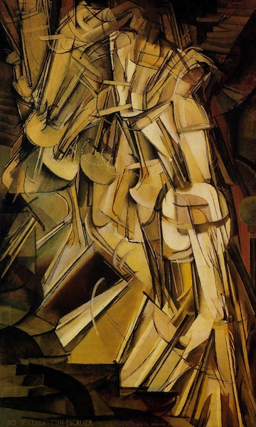 Image:

***Nude Descending a Staircase* (1912)**

**Marcel Duchamp**

#### 

#### ****“Nude Descending a Staircase****”

#### X. J. Kennedy, 1961

#### 

Toe upon toe, a snowing flesh,    
 A gold of lemon, root and rind,    
 She sifts in sunlight down the stairs    
 With nothing on. Nor on her mind.

We spy beneath the banister    
 A constant thresh of thigh on thigh—   
 Her lips imprint the swinging air    
 That parts to let her parts go by.

One-woman waterfall, she wears    
 Her slow descent like a long cape    
 And pausing, on the final stair    
 Collects her motions into shape.

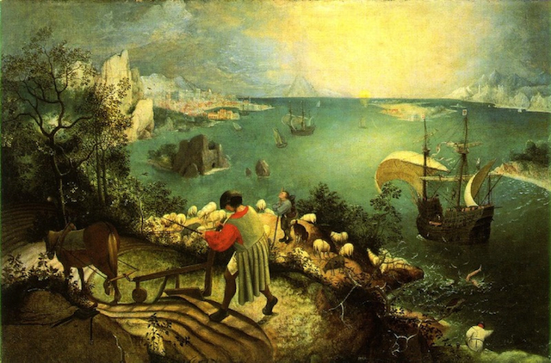**“Musée des Beaux Arts”**

**W. H. Auden (1938)**

About suffering they were never wrong,    
The Old Masters: how well they understood    
Its human position; how it takes place    
While someone else is eating or opening a window or just walking dully along;    
How, when the aged are reverently, passionately waiting    
For the miraculous birth, there always must be    
Children who did not specially want it to happen, skating     
On a pond at the edge of the wood:    
They never forgot    
That even the dreadful martyrdom must run its course    
Anyhow in a corner, some untidy spot    
Where the dogs go on with their doggy life and the torturer's horse     
Scratches its innocent behind on a tree.

In Brueghel's Icarus, for instance: how everything turns away    
Quite leisurely from the disaster; the plowman may    
Have heard the splash, the forsaken cry,    
But for him it was not an important failure; the sun shone    
As it had to on the white legs disappearing into the green    
Water; and the expensive delicate ship that must have seen    
Something amazing, a boy falling out of the sky,    
Had somewhere to get to and sailed calmly on.

Image:

**Landscape with the Fall of Icarus (1558)**

**Pieter Bruegel the Elder**

It takes a while for us to spot the pale legs kicking in the green sea to the right of the picture, since Bruegel’s great painting shows the fall of Icarus as an incidental occurrance, not the main event of this scene. But the insignificance of human suffering to the universe is indeed its theme. The plowman carries on with his task, while the “expensive, delicate ship”, after no doubt witnessing the incident, had “somewhere to get to and sailed calmly on.” The Imagist poet William Carlos Williams was also inspired to write a poem about this painting, as well as another famous Bruegel work.

#### ieter Bruegel the Elder, Hunters in the Snow, 1565, Kunsthistorisches Museum, Vienna “Hunters in the Snow”

#### William Carlos Williams, 1962

The over-all picture is winter   
 icy mountains   
 in the background the return

from the hunt it is toward evening   
 from the left   
 sturdy hunters lead in

their pack the inn-sign   
 hanging from a   
 broken hinge is a stag a crucifix

between his antlers the cold   
 inn yard is   
 deserted but for a huge bonfire

that flares wind-driven tended by   
 women who cluster   
 about it to the right beyond

the hill is a pattern of skaters   
 Brueghel the painter   
 concerned with it all has chosen

a winter-struck bush for his   
 foreground to   
 complete the picture

Image:

***Hunters in the Snow*** **(1565)**

**Pieter Bruegel the Elder**

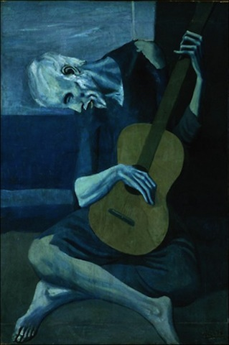

#### “The Man with the Blue Guitar,” Wallace Stevens, 1937

I III

The man bent over his guitar, Ah, but to play man number one,  
A shearsman of sorts. The day was green. To drive the dagger in his heart,  
  
They said, “You have a blue guitar, To lay his brain upon the board  
You do not play things as they are.” And pick the acrid colors out,  
  
The man replied, “Things as they are To nail his thought across the door,  
Are changed upon the blue guitar.” Its wings spread wide to rain and snow,  
   
And they said then, “But play, you must, To strike his living hi and ho,  
A tune beyond us, yet ourselves, To tick it, tock it, turn it true,  
  
A tune upon the blue guitar To bang if form a savage blue,  
Of things exactly as they are.” Jangling the metal of the strings . . .   
  
II IV  
I cannot bring a world quite round, So that’s life, then: things as they are?  
Although I patch it as I can. It picks its way on the blue guitar.  
  
I sing a hero’s head, large eye A million people on one string?  
And bearded bronze, but not a man, And all their manner in the thing  
  
Although I patch him as I can And all their manner, right and wrong,  
And reach through him almost to man. And all their manner, weak and strong?  
  
If to serenade almost to man The feelings crazily, craftily call,  
Is to miss, by that, things as they are, Like a buzzing of flies in the autumn air,  
  
Say that it is the serenade And that’s life, then: things as they are,  
Of a man that plays a blue guitar. This bussing of the blue guitar.

Image: **The Old Guitarist (1903), Pablo Picasso**

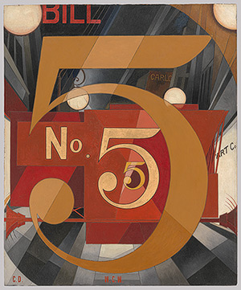 Image:

***I Saw the Figure 5 in Gold* (1928)**

**Charles Demuth**

**“The Great Figure”**

**William Carlos Williams (n.d.)**

Among the rain

and lights

I saw the figure 5

in gold

on a red

firetruck

moving

tense

unheeded

to gong clangs

siren howls

and wheels rumbling

through the dark city.