Steven Lora
LTS 353
Prof. Burns
Lehman College
United Palace: Solidarity In The Arts at The Heights
There is a place a block wide in the famous Washington Heights neighborhood that is not only a snapshot of history nearly a century ago. It is a place of deep Christian spirituality, focusing on lifting yourself from poverty. It is also one of the best ways to watch films as they were intended before the era of streaming or even before the era of CDs or VHS. So much so that one man, well known in the community, bought and restored that very same place after watching 2001: Space Odyssey. He would use that place as his home for his ministry, preaching, and choir. That place is the beautiful United Palace and that man is none other than Reverend Frederick J. Eikerenkoetter II, better known as Rev. Ike (1935-2009). After saving the United Palace, it would later turn into a historic landmark and one of the best places for Latino music, film, and literature as the neighborhood became more predominantly Latino, especially from the Dominican Republic. However, while there are plenty of Latino performances at the United Palace, there are still diverse groups of people that perform there, such as K-pop groups, black performances by black actors, a symphony concert based on Sonic The Hedgehog, and tributes to the Golden Era of Cinema from the 1930s to the 1970s. One example is the upcoming screening of Duck Soup by the famous Marx Brothers with discussions by a New Yorker journalist and film restoralist. The United Palace is also a famous place for film shoots and festivals for the community to join. This is a place with many connections to famous people and important people, right at Washington Heights.
The United Palace started as a premier vaudeville and movie house built in the 1930s, with its interior and exterior being seemingly inspired by Hindu Temples as the walls have statues of a Hindu goddess, either Saraswati or Lakshmi, and the heavy use of the gold motif. Which is heavily tied to the Hindu Mythos, as the creator of the universe, Brahma was born from a golden egg and is the source of the universe’s formation and a symbol of purity and immortality. Gold is a metal that will never rust, it has been used for centuries as jewelry, statues, currency, and on the walls of Hindu temples. Lakshmi is the goddess of prosperity and immortality whom people worship to bring material and spiritual wealth into their homes and temples. Of course, gold is also a symbol of wealth or power in most societies and cultures as well, as the Tabernacle in Christianity is usually made out of a gold-like metal. Also, gold is a symbol of incorruptible purity and has a high value to God. It’s a bit fitting that a place covered in gold would be in the same place where Rev. Ike would preach about lifting yourself from poverty and becoming wealthy to appease God. To better understand the history of the United Palace, I decided to go on a tour of the palace that included a tour guide and free drinks. Before it was named the United Palace, it was Loew's Wonder Theatre. Named after one of 5 Wonder Organs, a unique organ, the palace has the only remaining Wonder Organ left in working condition after nearly a century and was founded by Marcus Loew, on George Washington’s birthday, February 22, 1930. Loew’s Wonder Theatre was created during a transitioning yet booming era of cinema, between silent film and the “talkies”(sound film), the theater was built with both sound and silent films in mind with its architecture, according to the tour guide. The theater opened with a huge parade with the Boy Scouts, Loew’s Grand Orchestra, and more. Marcus Loew wanted to capitalize on the growing film and theater market during the 1920s-1930s. So, Loew’s founded the Loew’s Theater company and went on to create Metro Goldwyn Mayer after merging two film studios he had bought before, so that he could have “a steadier stream of films for his theaters at that point”, according to the tour guide at the United Palace. For 40 years, it was a place of film screenings and live performances by the likes of The Three Stooges and Jerry Lewis.
That was until the faithful screening of 2001: A Space Odyssey in 1969. At the time, theaters like Loew’s Wonder Theater were being demolished, likely due to high maintenance costs and low ticket sales. But after Rev. Ike saw the film and the theater, he fell in love with the place. He would purchase the theater for $600,000 and turn it into the United Palace of the Spiritual Arts, where he would perform and televise weekly sermons with a large production value watched by many. It was also the first of its kind to be broadcasted on the radio to thousands of followers and listeners as well. He would view the United Palace as the “do-it-yourself church” and he would preach under that same mindset. His message was mainly focused on getting money, quoting him, “I love money and money loves me”, that you can do anything you put your mind to, and being self-reliant. One particular quote from Rev. Ike that stood out to me was, “If it’s that difficult for a rich man to get into heaven, think how terrible it must be for a poor man to get in”, a twist on the famous bible verse that showcases his method of preaching. His preaching would go on and make him a multimillionaire and he owned several Rolls-Royce cars that he would drive in a fleet around the block every Sunday according to the tour guide. He would be often accused of shady tax practices and preying on poor people’s religious beliefs for monetary gain as many people would donate to him for his blessings and to appease God through the church in hopes that it would bless them with future wealth or health. Although some would argue that his teachings were appealing to those who wished that their hard work should be rewarded according to his obituary. However, Rev. Ike would also spend millions on restoring the United Palace as well. By some twist of fate or some stroke of destiny, both Marcus Loew and Rev. Ike grew up in poverty, became well-known in the Hollywood space, worked in the same place, and became highly successful men. I wouldn’t have known about Rev. Ike and his importance to the story of The United Palace if it weren’t for my Uncle Luis, who grew up in the Heights in an apartment next to the United Palace with my mother and grandma. Who said to me and my mother, “His name is Reverend Ike, he’s real famous, real famous for that church. That’s probably has a big part of the history that has to do with that church. (People) that don’t live in this community and they know who he was”
After Rev. Ike’s passing in 2009, his son continued the spiritual aspect of the United Palace, with services and religious programs. But since 2012, the CEO, Mike Fitelson, decided to have the United Palace return to its roots as a movie theater and a place for plays, concerts, and award ceremonies, most notable being the 2023 Tony Awards. Mike Fitelson is a friend of Lin Manuel Miranda, creator of Hamilton: An American Musical, In The Heights, and songwriter for Disney’s Encanto and Moana, who grew up in Washington Heights. So the CEO asked Lin if he wanted “to do something at this theater”, which led Lin to do a special anniversary concert of In The Heights and the relationship between Lin and United Palace started to build. After this, the CEO asked for a consistent program that Lin could add to the United Palace and that’s when The Movies We Missed and Movies at The United Palace with Lin Manuel Miranda events started. Films are voted on by the community during the holiday season and once a month, a free film screening with a dialogue between Lin Manuel Miranda and an actor or director of that film occurs. Last month, me and my brother went to the free screening of Blue Beetle with a dialogue between Lin and the film’s director, Angel Soto. The theater became packed and there were cheers, laughter, and discussions of Latino representation, language, and stories of actors of the film bonding with each other between Lin and Angel Soto. Lin also helped in the restoration of the United Palace by donating $100,000 for a better film screen. Lin would go on to say, “There is no other theater like the United Palace in New York City, or around the world, really. This theater is special. It’s breathtaking. You don’t just come to sit and watch a movie here; you are transported.”, I guess that is another part of the wonder in Loew’s Wonder Theater. If you are interested, I would recommend you go there for a film, concert, or book openings that are usually free or $5, with the exception of concerts of course.
To know more about the block a bit more, I asked someone who has worked at The United Palace for an email interview. The CEO himself replied and agreed to forward my request to a Latino employee to answer my questions. They were very kind but busy, so it took a while for a reply. My request was forwarded to Joan Guzman, the Director Of Operation of the United Palace. Joan was born in New York but his family is from the Dominican Republic. According to him, United Palace’s architecture has been relatively the same since the 1930s but continues to modernize the theater’s technological capabilities while restoring its exterior and interior. Joan and the United Palace hope to conclude its restoration project by the theater’s 100th anniversary. Joan mentioned that their project includes, “recarpeting the entire theatre, installing modern sound and lighting equipment, and digitizing our exterior attraction boxes.”, thus making the theater experience for both filmmakers, playwrights, and viewers better for all. When I first looked at the United Palace on Google Maps, I was surprised that it was in a block named Little Dominican Republic, I wondered how and when this block got its name. So I asked Joan and he said, “Our neighborhood was designated Little Dominican Republic in September 2018 due to being one of the largest Dominican communities in the world.”, which I didn't know until the email exchange. I was also curious about his experience working in the theater. Then I asked Joan about his time working at the United Palace, he replied, “At the start of my employment in 2005, I was studying to be a nurse. I was hired by Rev. Ike as a receptionist onsite and his assistant via fax machine. Rev. Ike then became very ill and I started working less and less with him. I then got involved in all the building-related issues and events and worked my way up. I never thought this was the career path I was going to take. I am now the Director of Operations. I feel honored to be able to manage one of Manhattan’s largest and most spectacular theatres and that it brings joy to the thousands of people who walk through our doors every year. I love what I do. I love to be a part of all the different productions our building has to offer.”, another great story of humble beginnings to great success. Of course, I also wondered about the state of United Palace, as COVID-19 threatened many businesses, especially movie theaters so I inquired with Joan about the times the theater was close to being shut down as the movie industry has been known to have high and low periods. Joan replied, “Believe it or not, way back in 1969, the United Palace (then known as the Loew’s 175th Street) was slated for potential demolition, at a time when single-screen movie theatres were being threatened by the rise of multiplexes and television. Thankfully, Rev. Ike and his church purchased the building, saving it from demolition, and renamed it the United Palace. Then in 2020, the pandemic challenged our organization just as much as it did other venues. With a lack of live events, we sought out other activity to keep busy, including hosting film productions and supplying storage space for the local hospital.”, which seems to be helpful for the neighborhood’s economy and its health during the Covid 19 crisis. I thanked Joan for his time answering my questions so that I could have a deeper understanding of the history of both the United Palace and the neighborhood it resides in.
The United Palace is a place inspired by Hindu mythology, a place made during the Golden Era of Cinema by an American pioneer, a place of an iconic black gospel preacher and his flashy televised sermons, a place of support for the community and the locals, a place where the movie industry’s biggest stars come and have film shoots, award shows, and discussions for both actor and the audience to enjoy and to celebrate how far the movie industry has come. The United Palace became a place where people began their successful careers while giving back to the neighborhood that gave them that opportunity. The United Palace is also a place where a diverse group of people from around the world, from other Latin American countries, from Asia, and diverse groups of people who live in New York can come and perform for a wide audience. The United Palace is truly a one-of-a-kind wonder theater.

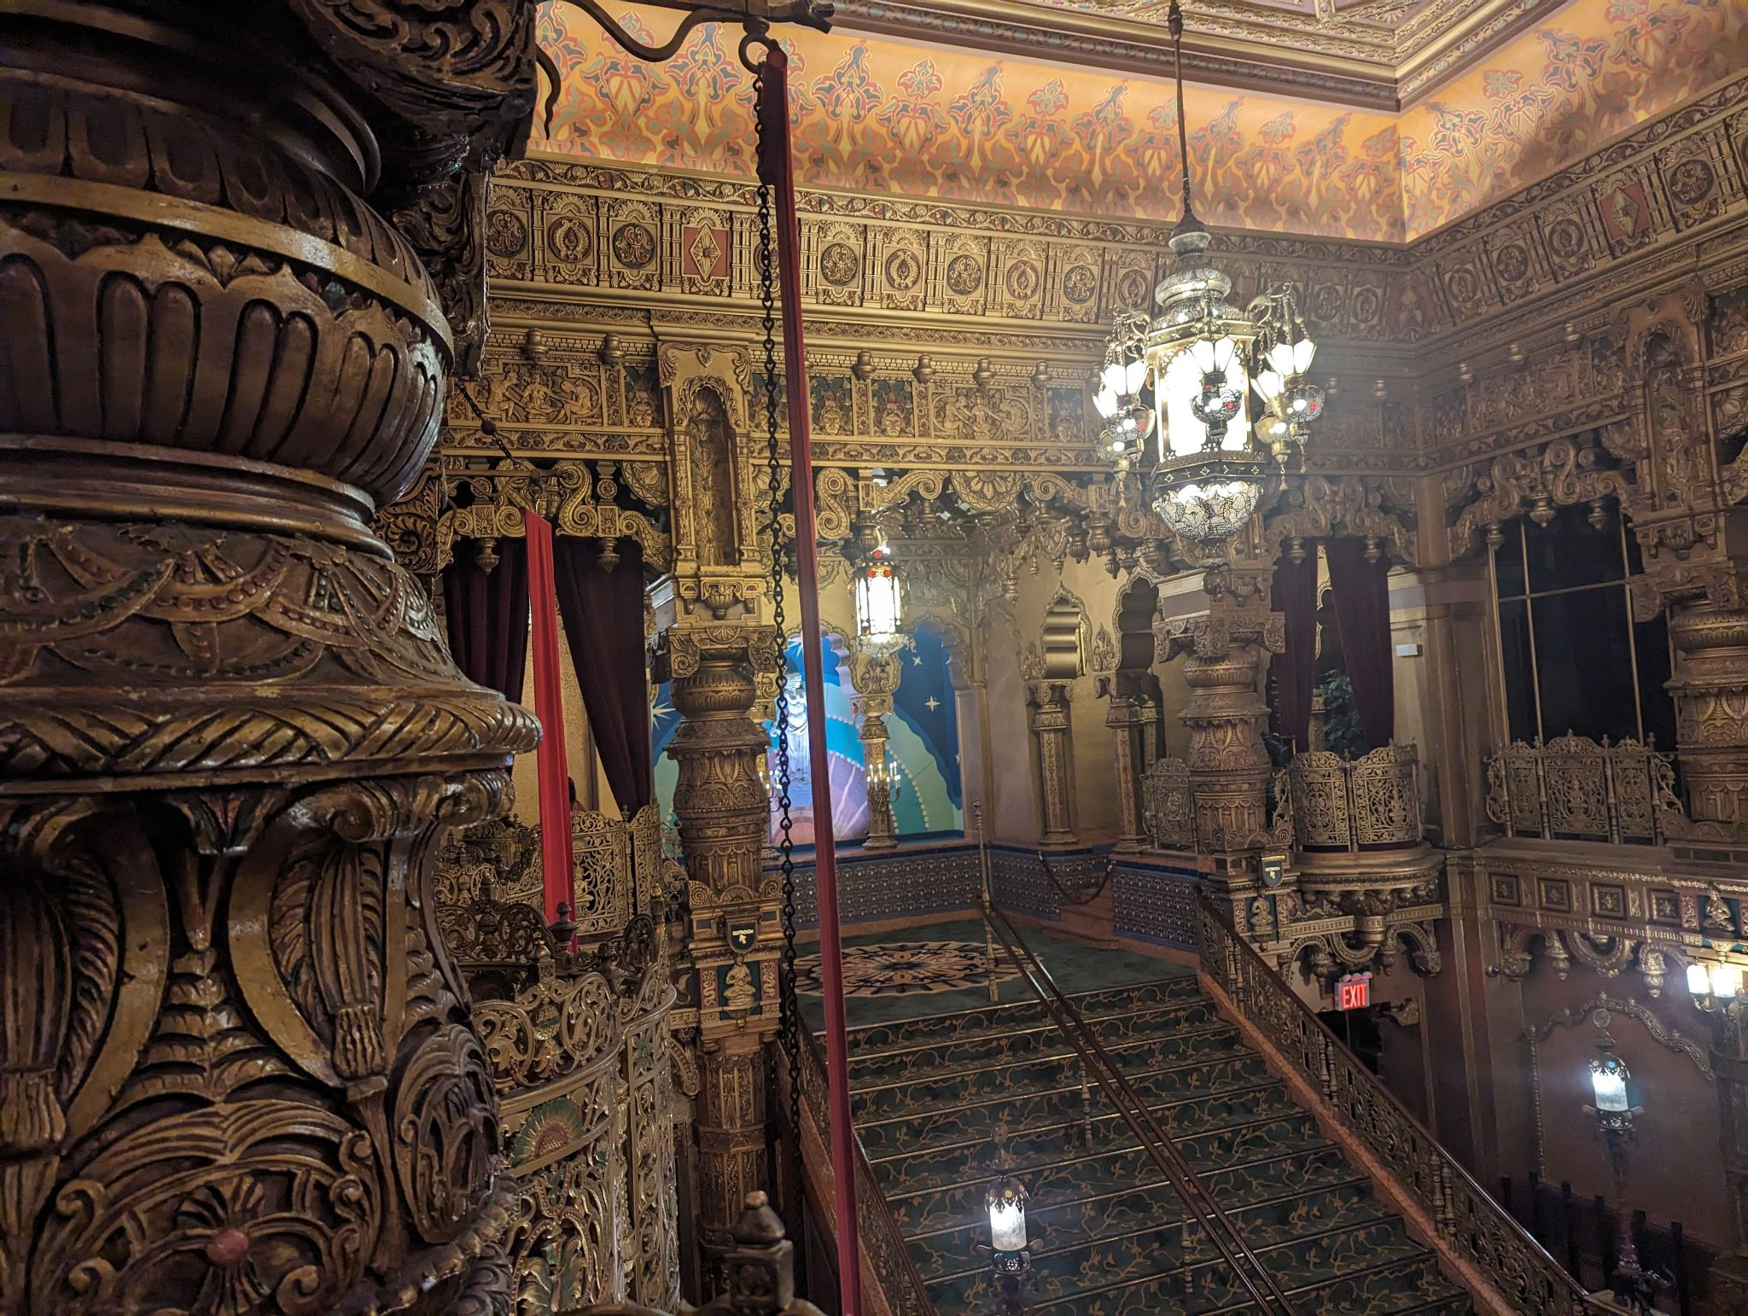
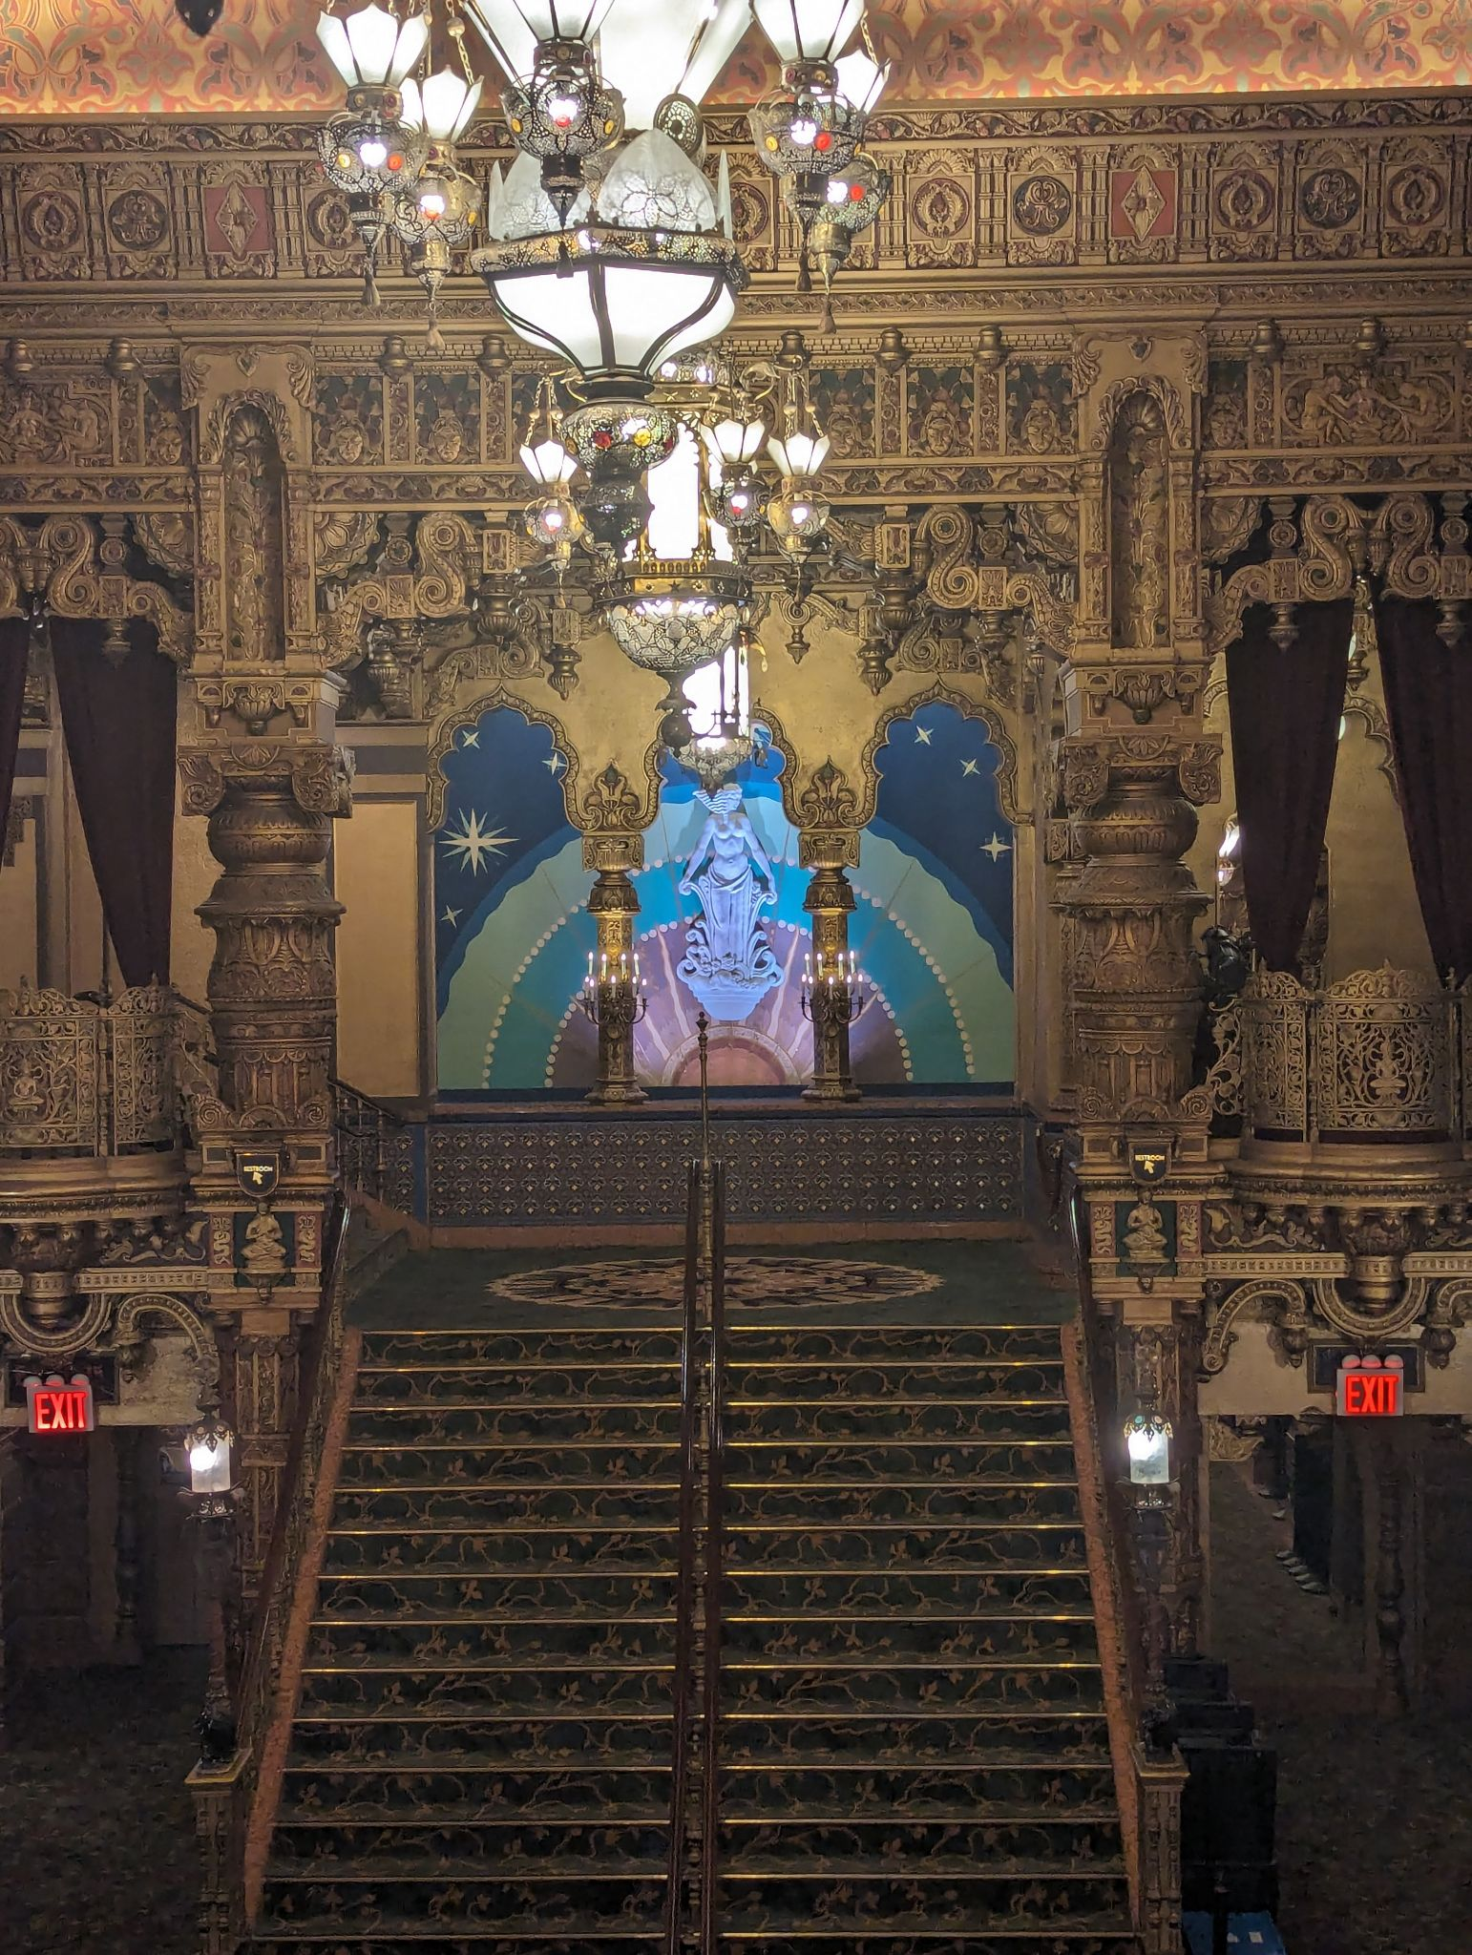
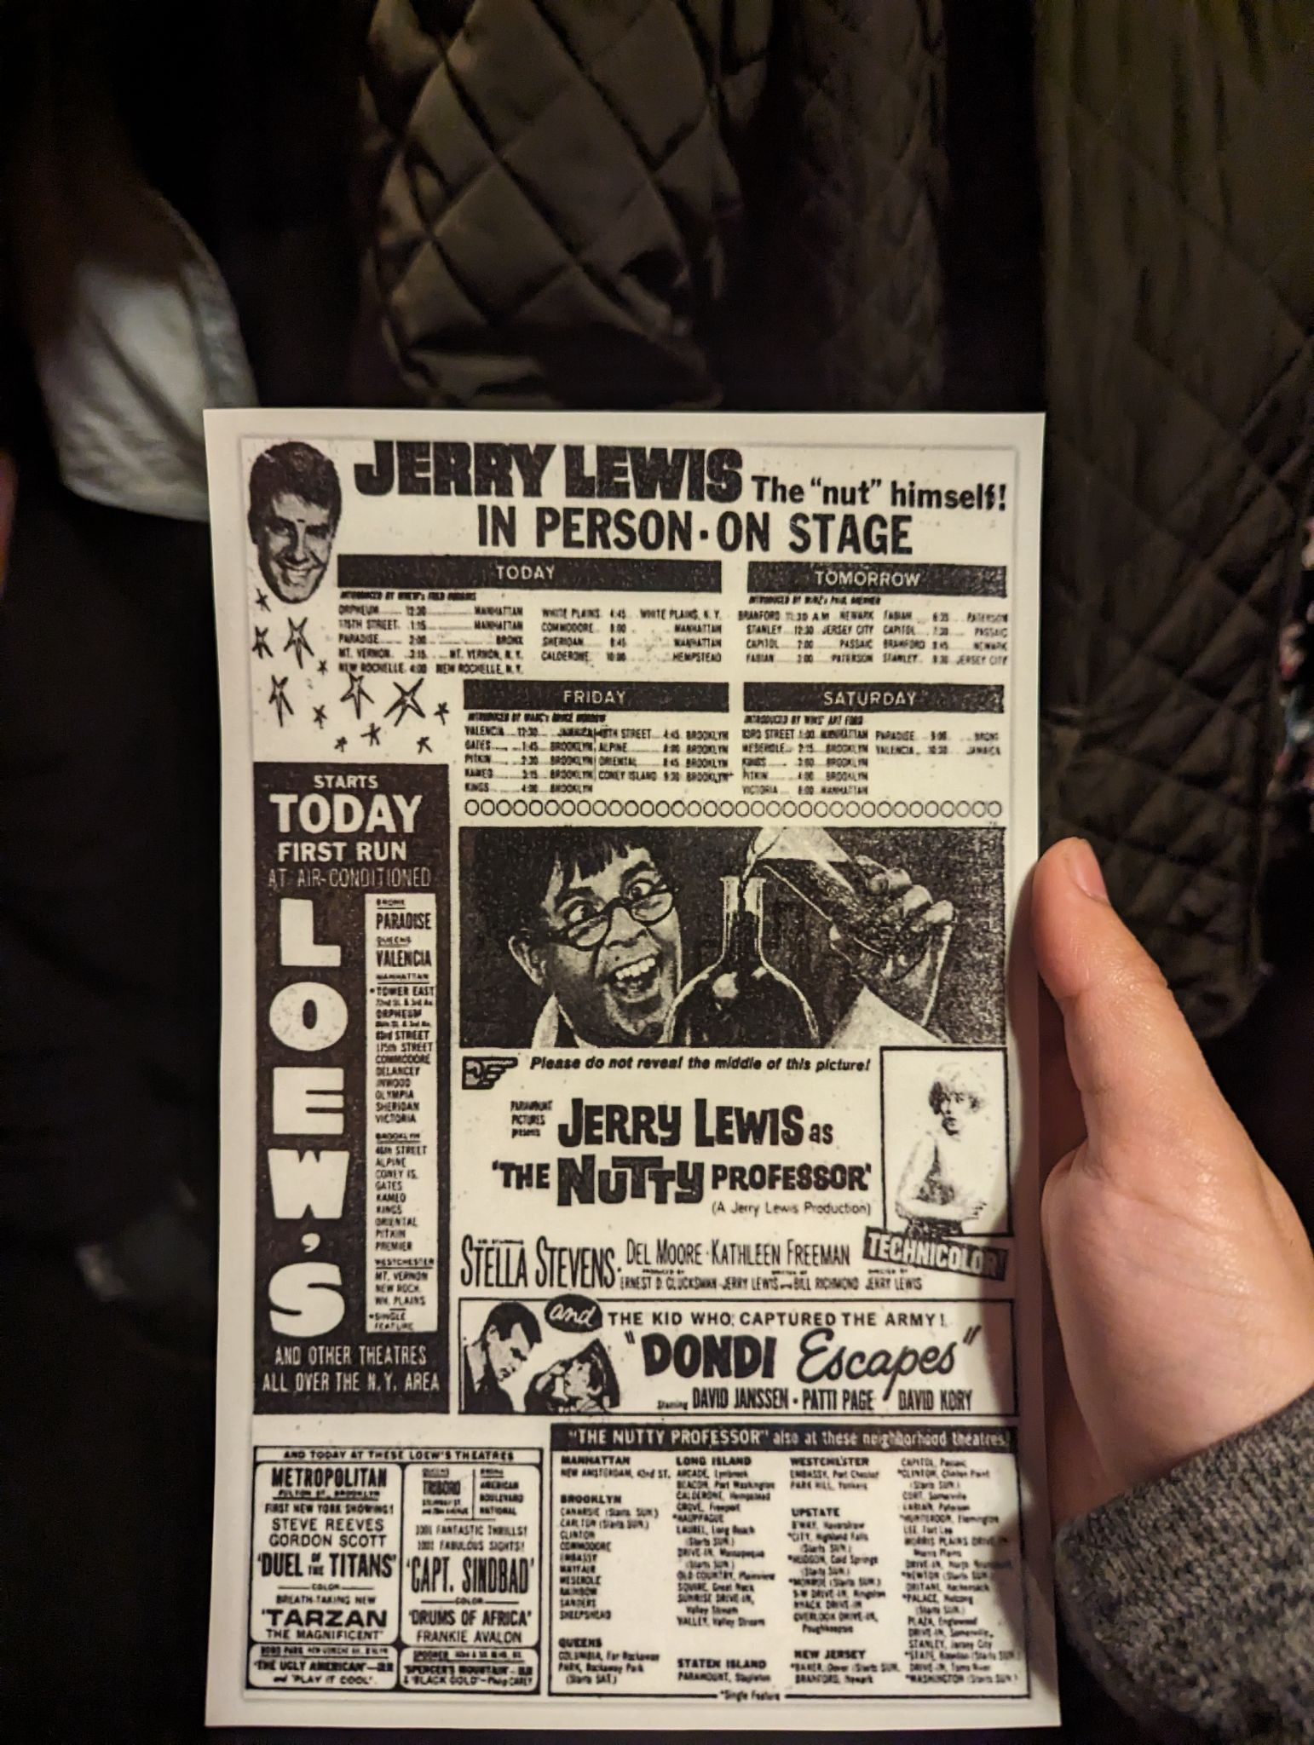
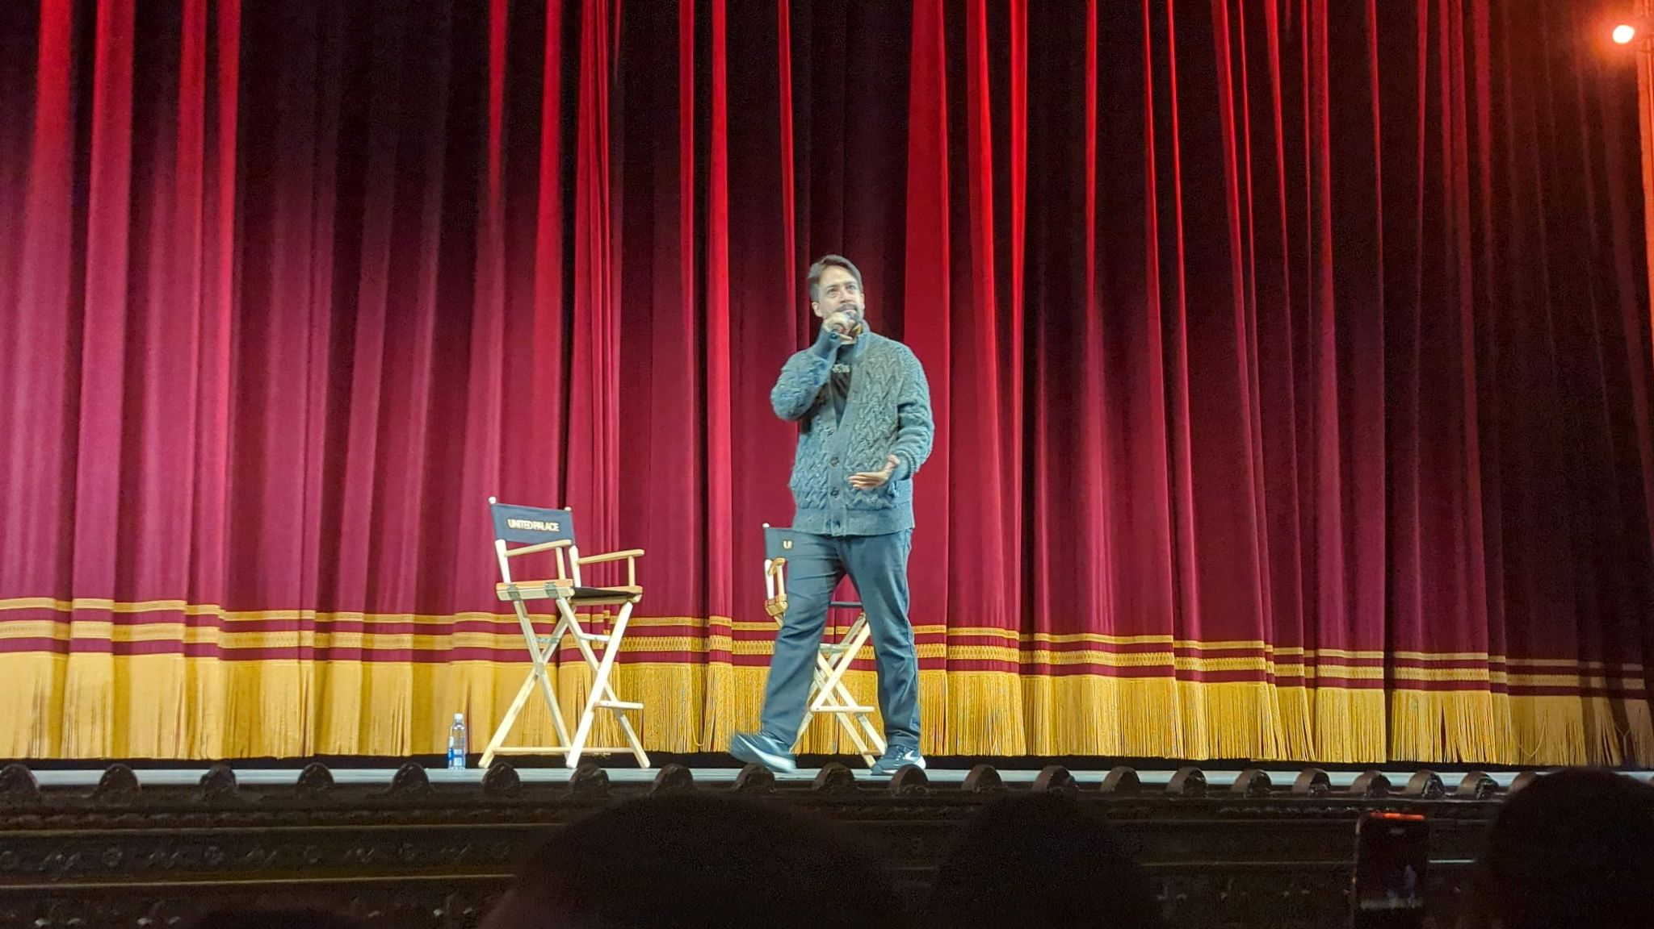
Lin Manuel Miranda
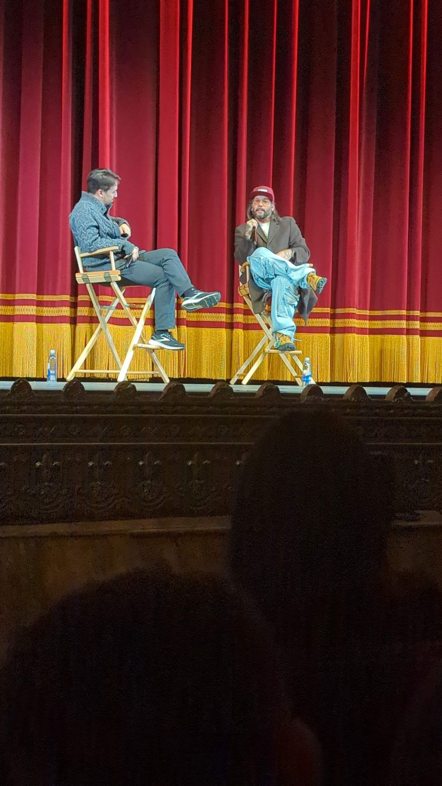
Lin Manuel Miranda(Left) and Angel Soto (Right)

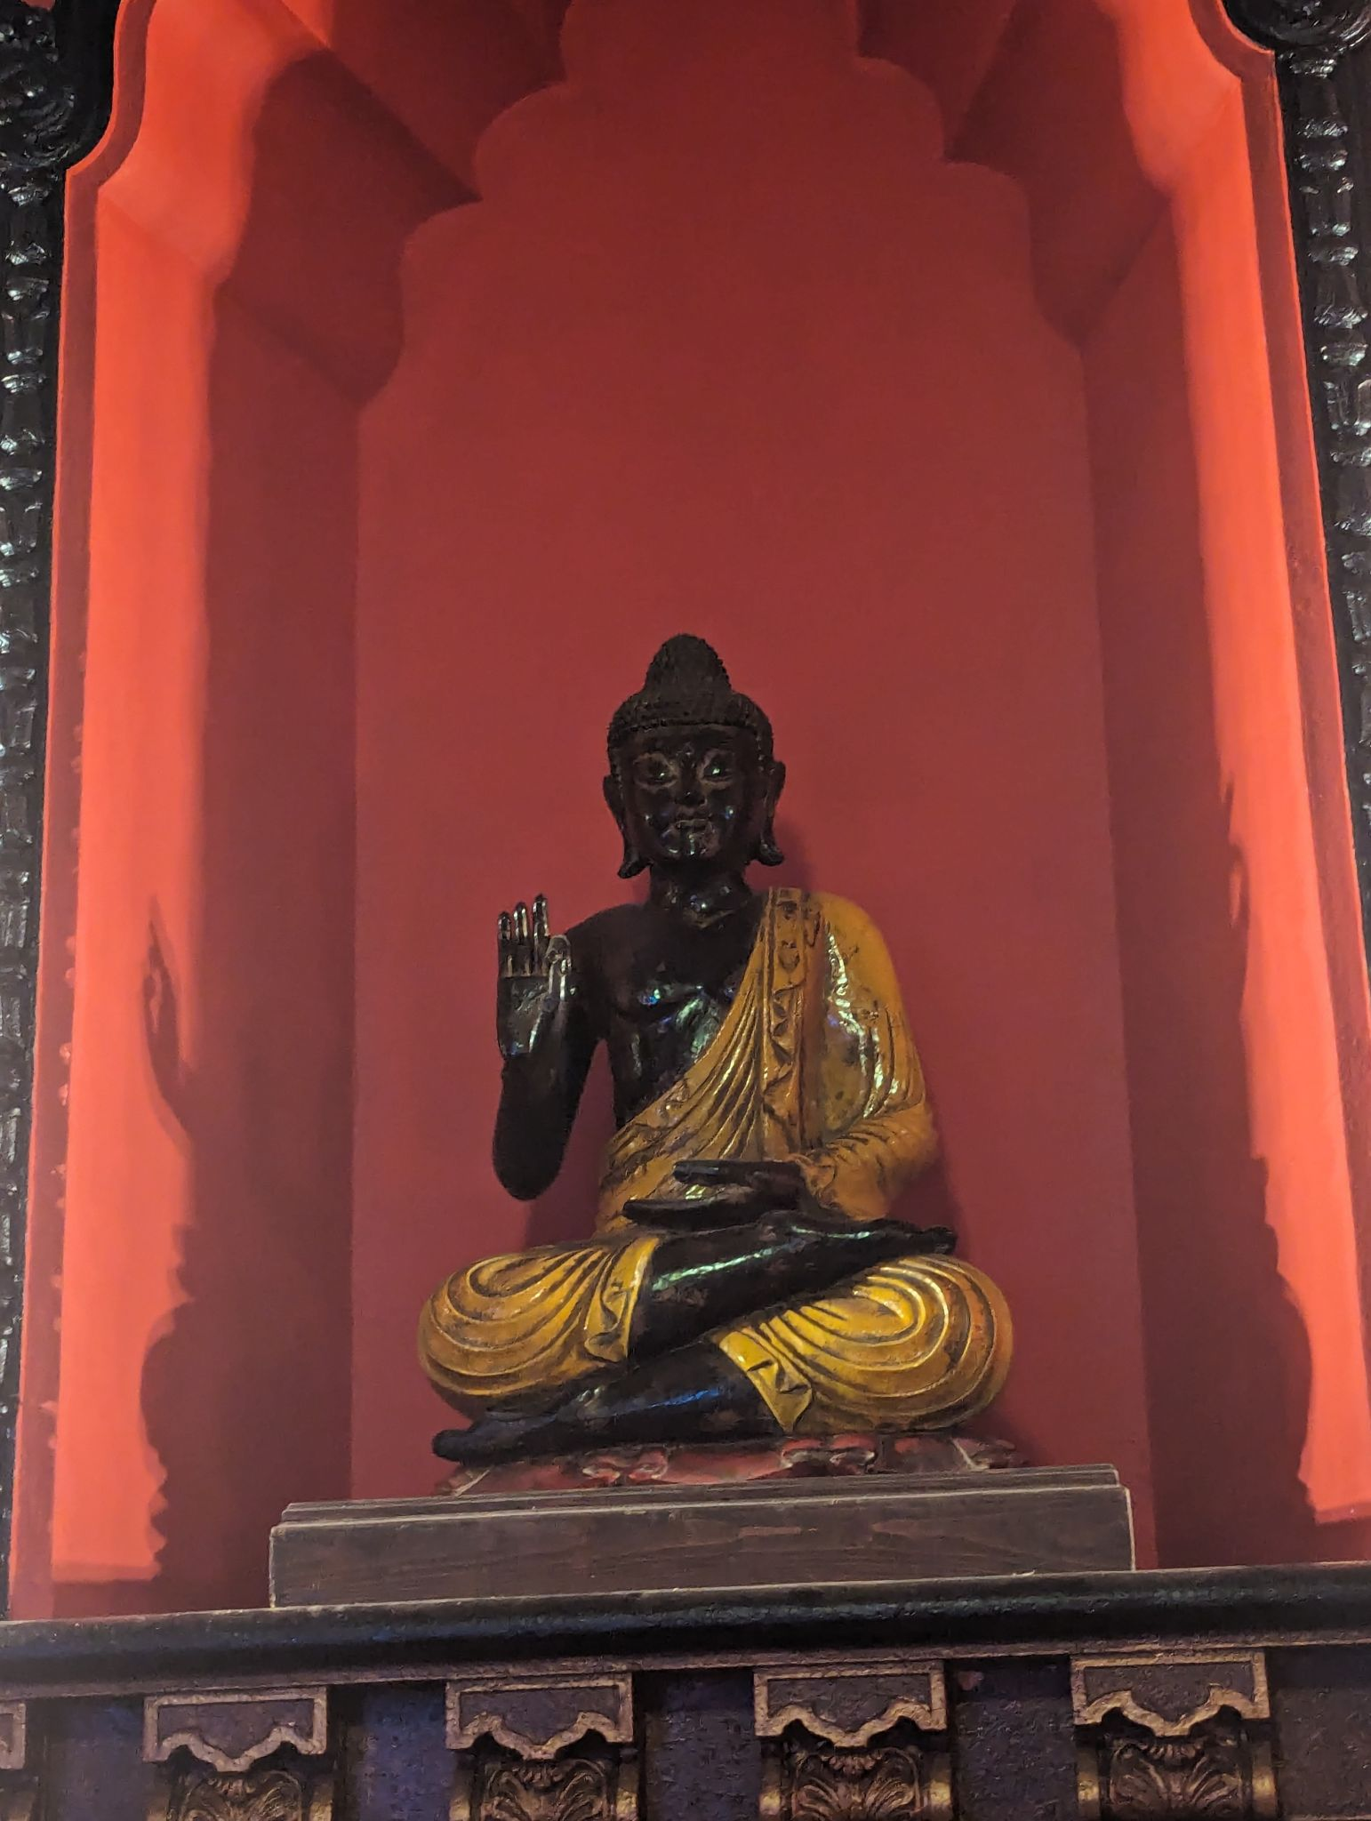Sources:
http://s-media.nyc.gov/agencies/lpc/lp/0656.pdf
Winchell, Louisa. “Beyond the Village and Back: The United Palace Theatre - Village Preservation.” Village Preservation - Greenwich Village Society for Historic Preservation, 10 Jan. 2022, www.villagepreservation.org/2019/12/11/beyond-the-village-and-back-the-united-palace-theatre/.
“Gold in the Bible: More than Glitter and Glamour.” RSS, www.christianpure.com/blog/gold-symbolism-bible. Accessed 29 Apr. 2024.
Baker, Vicky. “The Preachers Getting Rich from Poor Americans.” BBC News, BBC, 28 May 2019, www.bbc.com/news/stories-47675301.
Barron, James. “Working to Revive a Movie House That Lived in a Palace.” The New York Times, The New York Times, 21 June 2013, archive.nytimes.com/cityroom.blogs.nytimes.com/2013/06/21/working-to-again-light-up-the-big-screen-in-a-majestic-home/.
Legacy.com, and Legacy. “Reverend Ike Obituary (2009) - Cleveland, OH - Cleveland.Com.” Legacy.Com, Legacy, 30 July 2009, obits.cleveland.com/us/obituaries/cleveland/name/reverend-ike-obituary?pid=130613017.
“Marcus Loew.” Hollywood Walk of Fame, 9 Dec. 2020, walkoffame.com/marcus-loew/.
Unitedpalace.Org, www.unitedpalace.org/leadership/. Accessed 29 Apr. 2024.
“About Rev. Ike.” Reverend Ike, www.revikelegacy.com/about-revike. Accessed 29 Apr. 2024.
Carlin, Dave. “United Palace Gets Ready for Its Moment in the Spotlight as the Tony Awards Move to Washington Heights.” CBS News, CBS Interactive, 8 June 2023, www.cbsnews.com/newyork/news/united-palace-washington-heights-tony-awards/.

